Sample Logs

/var/log/server_health.log, output:

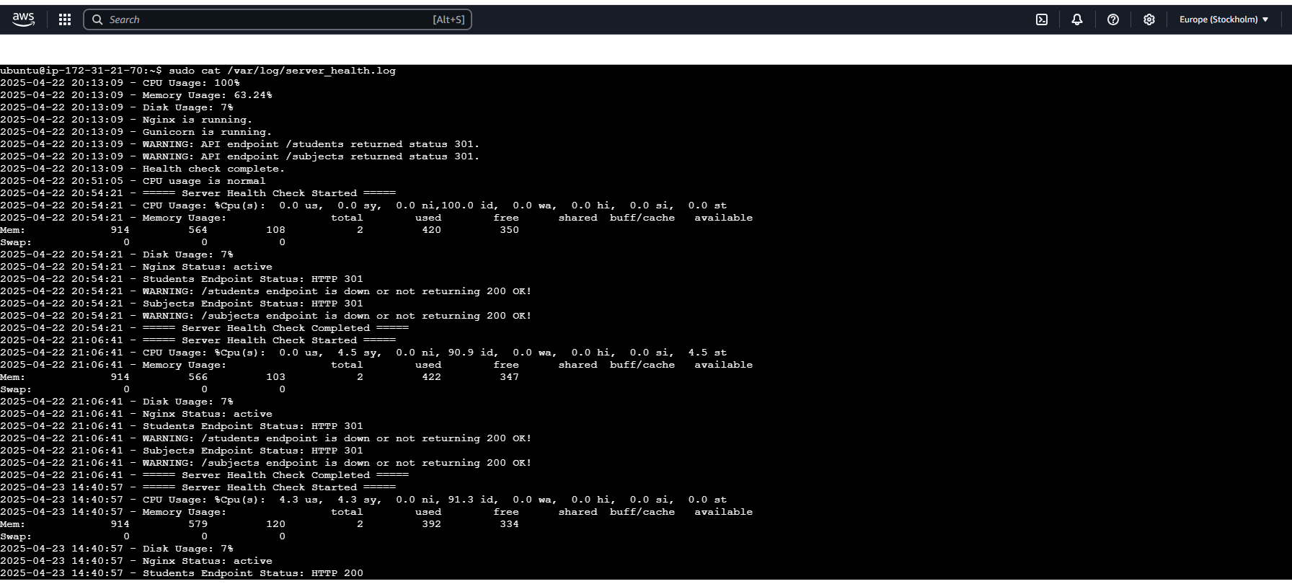

/var/log/backup.log, Output:

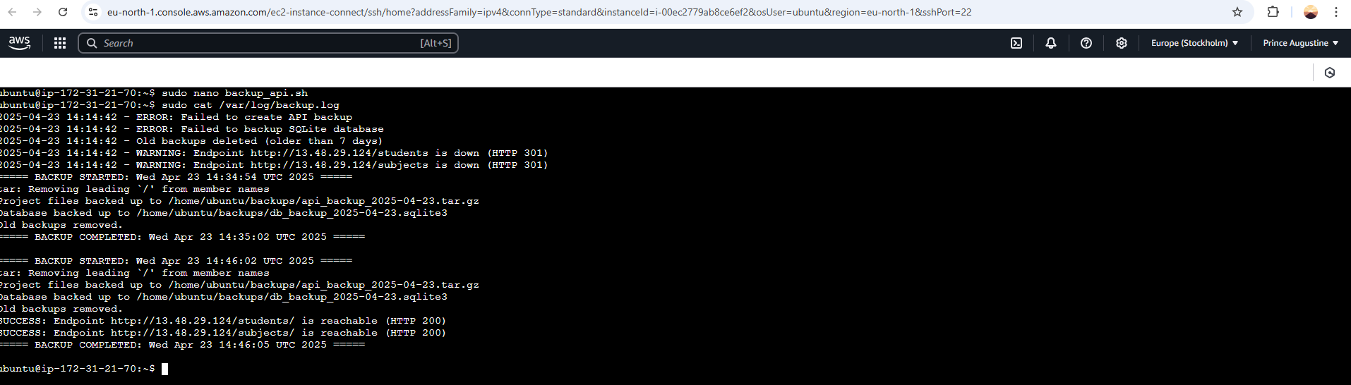

/var/log/update.log, Output:

